Operating Instructions
Suitable for the models with D81-03 of E400series and E401series
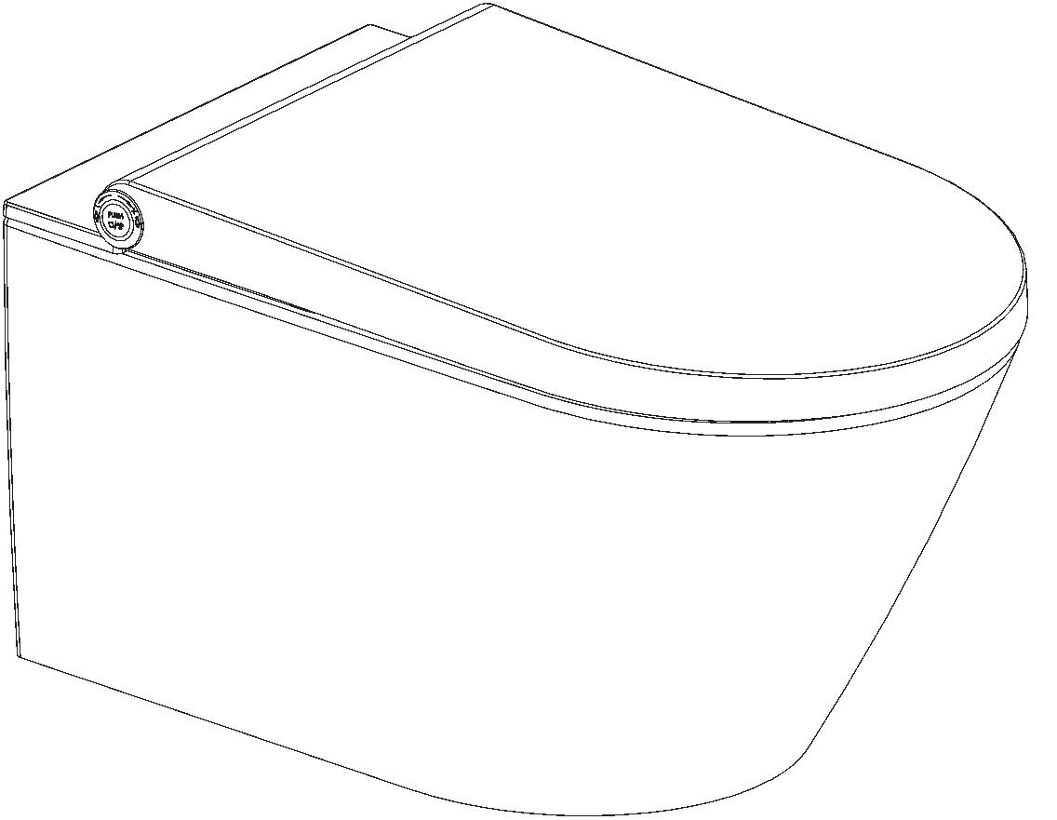

Safety precautions
Explanation of symbols
Refers to potentially dangerous situation that may cause serious injury or death .
DANGER
Refers to potentially dangerous situation that may cause injury or property losses .
NOTICE
FORBID
Refers to forbidded to do .
Refers to abide by the rules .
MUST BE ABIDED
The supplier shall not be liable for any loss arising from the failure to
comply with the following regulations
DANGER
1.This equipment is “I” type electric appliance, must be completed
connected to the grounding system.
2.If the supply cord is damaged, it must be replaced by the
manufacturer, its service agent or similarly qualified persons in
order to avoid a hazard.
3.This equipment is electric appliance, please do not be installed at
the place where can easily be splashed with water or high temperature.
Please install exhaust fan or ventilation opening to make sure there
is a good ventilation when using at Bathroom.
4.This appliance can be used by children below 3 years but require
constant observation by an adult in the immediate proximity of the
child.This appliance can be used by children aged from 3 years and above
and persons with reduced physical,sensory or mental capabilities or lack
of experience and knowledge if they have been given supervision or
instruction concerning use of the appliance in a safe way and
understand the hazards involved.Children shall not play with the appliance.
Cleaning and user maintenance shall not be made by children without
supervision.
5.The appliance will be permanently connected to the water pipe. Remove
the water pipe assembly except for installation and maintenance.
6.The portable residual current device(PRCD) is optional. The PRCD must
be reliably fixed.
1
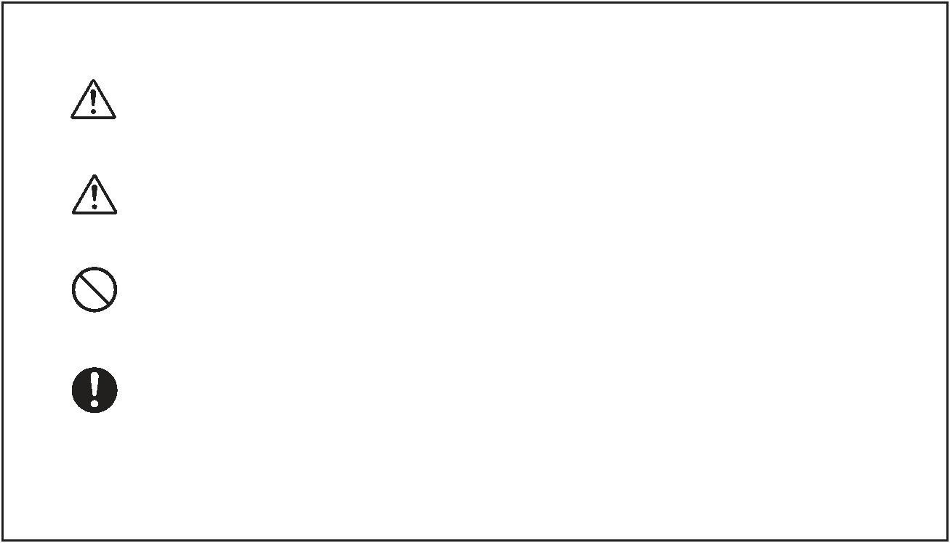

Safety precautions
1. Do not insert or remove power plug with wet
hands. Otherwise there is a risk of electric
shock.
Do not damage the power cord and plug.
Otherwise there is a risk of electric
shock, short-circuit and fire.
FORBID
2.
3.
Do not use the loose socket.
Otherwise there is a risk of electric shock and fire.
4.
The power supply must be accorded with regulation.
Otherwise there is a risk of damage the product and fire.
5.
Do not disassemble, repair or reassemble the product.
Otherwise there is a risk of electric shock and fire.
6. Do not place a stove or a cigarette near the product.
Otherwise there is a risk of fire.
7.
Make sure not to splash water, detergents or urine on the
product and the power plug.
Otherwise there is a risk of electric shock,
damage the product and fire
8.Do not turn the product upside-down.
Otherwise this might cause product damage.
9.Do not bend or distort the inlet hose.
Otherwise there is a risk of water leakage.
10.The new hose-sets supplied with the appliance are to be
used and the old hose-sets should not be reused.
2
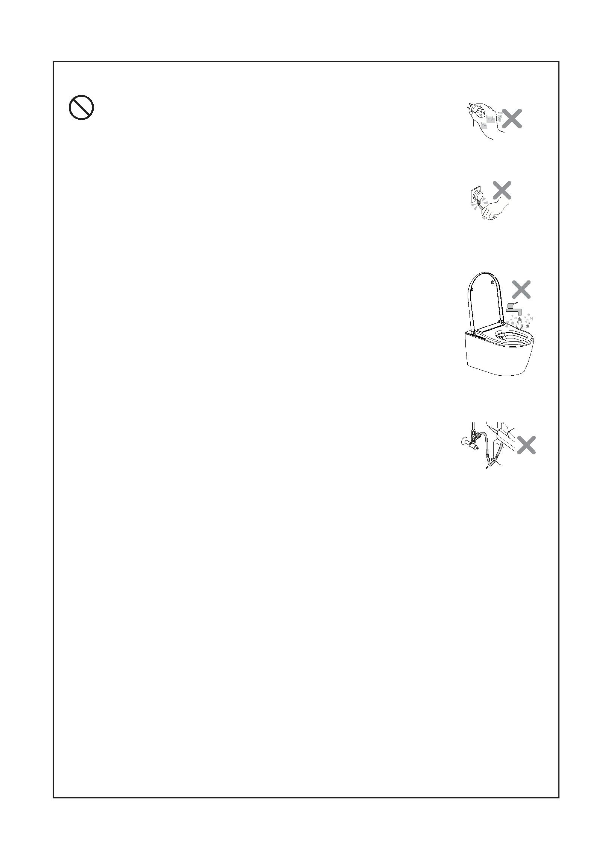

Technical Specification
E400-W011
E401-W011
MODEL
E400-F011
Rear Wash
Female Wash
Massage
●
●
●
Wash
Adjustable Water Temperatur
OFF/5 Steps（Default 3rd)
Adjustable Flow Rate
5 Steps（Default 3rd)
Adjustable Spray Position
Air Drying
5 Steps（Default 5th)
●
Warm Air
Heated Seat
Hygiene
Adjustable Air Rate
Adjustable Dryer Temperatur
Heated Seat
Adjustable Seat Temperature
Deodoriser
Nozzle Automatic Cleaning
Nozzle Manual Cleaning
Descaling
5 Steps（Default 3rd)
OFF/5 Steps（Default 3rd)
-
-
●
●
●
-
User Mode
-
D81-03
Remote Control
Night Light
Breathing Lamp
●
●
Soft Closing Seat And Cover
Body Knob
-
●
Rimless Toilet
●
Installation of the toilet
Wall-hung /Pedestal
Water Supply Connector
Rated Voltage
Power
G 3/8
AC220-240V，50/60HZ
1170W
Length Of Power Cord
Water Supply Pressure
Water Supply Temperature
Ambient Temperature
Protection Degree
Flow Rate
1.8m
0.07～0.75MPa(0.7～7.5Bar)
4～35℃
4～40℃
IPX4
350～650mL/min
31～39℃
Water Temperature
Wash Cycle Time
3 Minutes
Wash Device Heating Mode
Tank
Heater Power
Safety Device
Backflow Prevention
Speed Of Air
1200W
Thermal Cutoff Fuses\Liquid Level Switch\Thermostat
Air Gap of AB type
≥4m/S
Dryer Power
Dry Device Dry Cycle Time
250W
3 Minutes
Warm Air Temperature
35～50℃
Safety Device
Thermal Cutoff Fuses\Thermostat
Deodorization Mode
Deodorization Cycle Time
Heated Power
Diatom
Deodorization
Heated Seat
15Minutes
-
-
Seat Temperature
Safety Device
-
Frequency Range
2460MHz
Maximum RF Output Power
-10dBm
Remote Control Type of batteries
Number of batteries
Other Safety Device
Net Weight
3V CR2032
Two Pieces
Residual Current Devices
35Kg
Dimension
593*384*388 mm
Technical upgrade will be edited into the new version instruction without additional notice.
Please follow the real if it is different from the nominal in shape ,color and accessories.
3
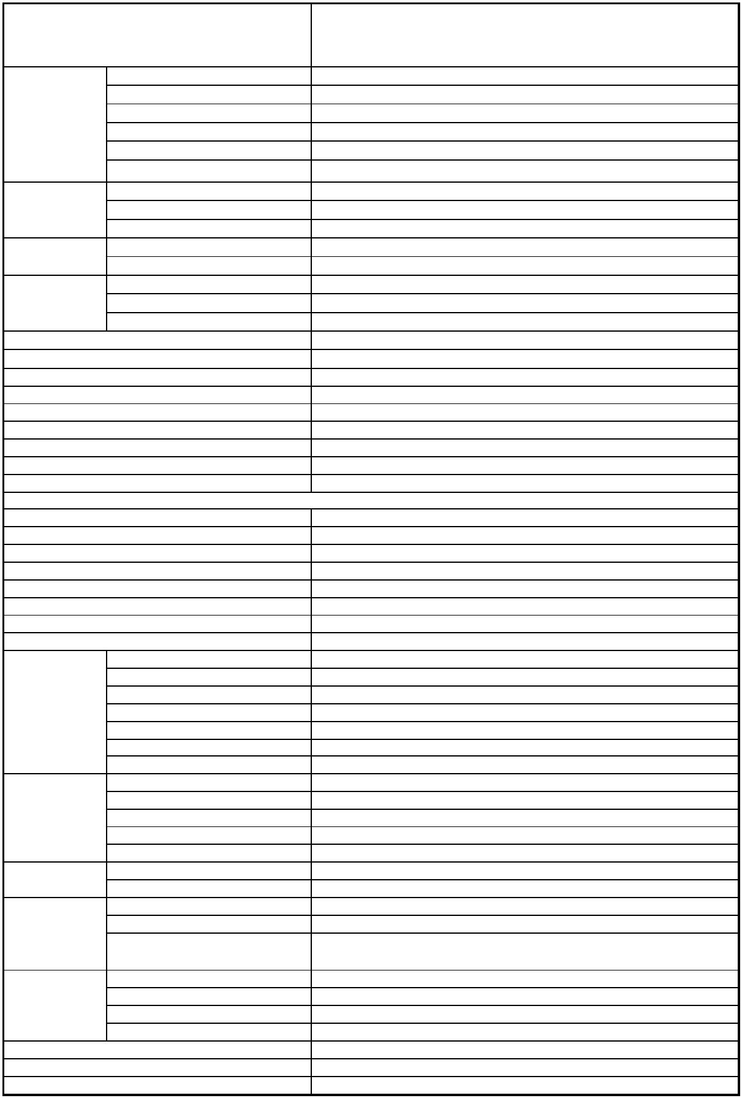

Technical Drawing
E400-W011
4
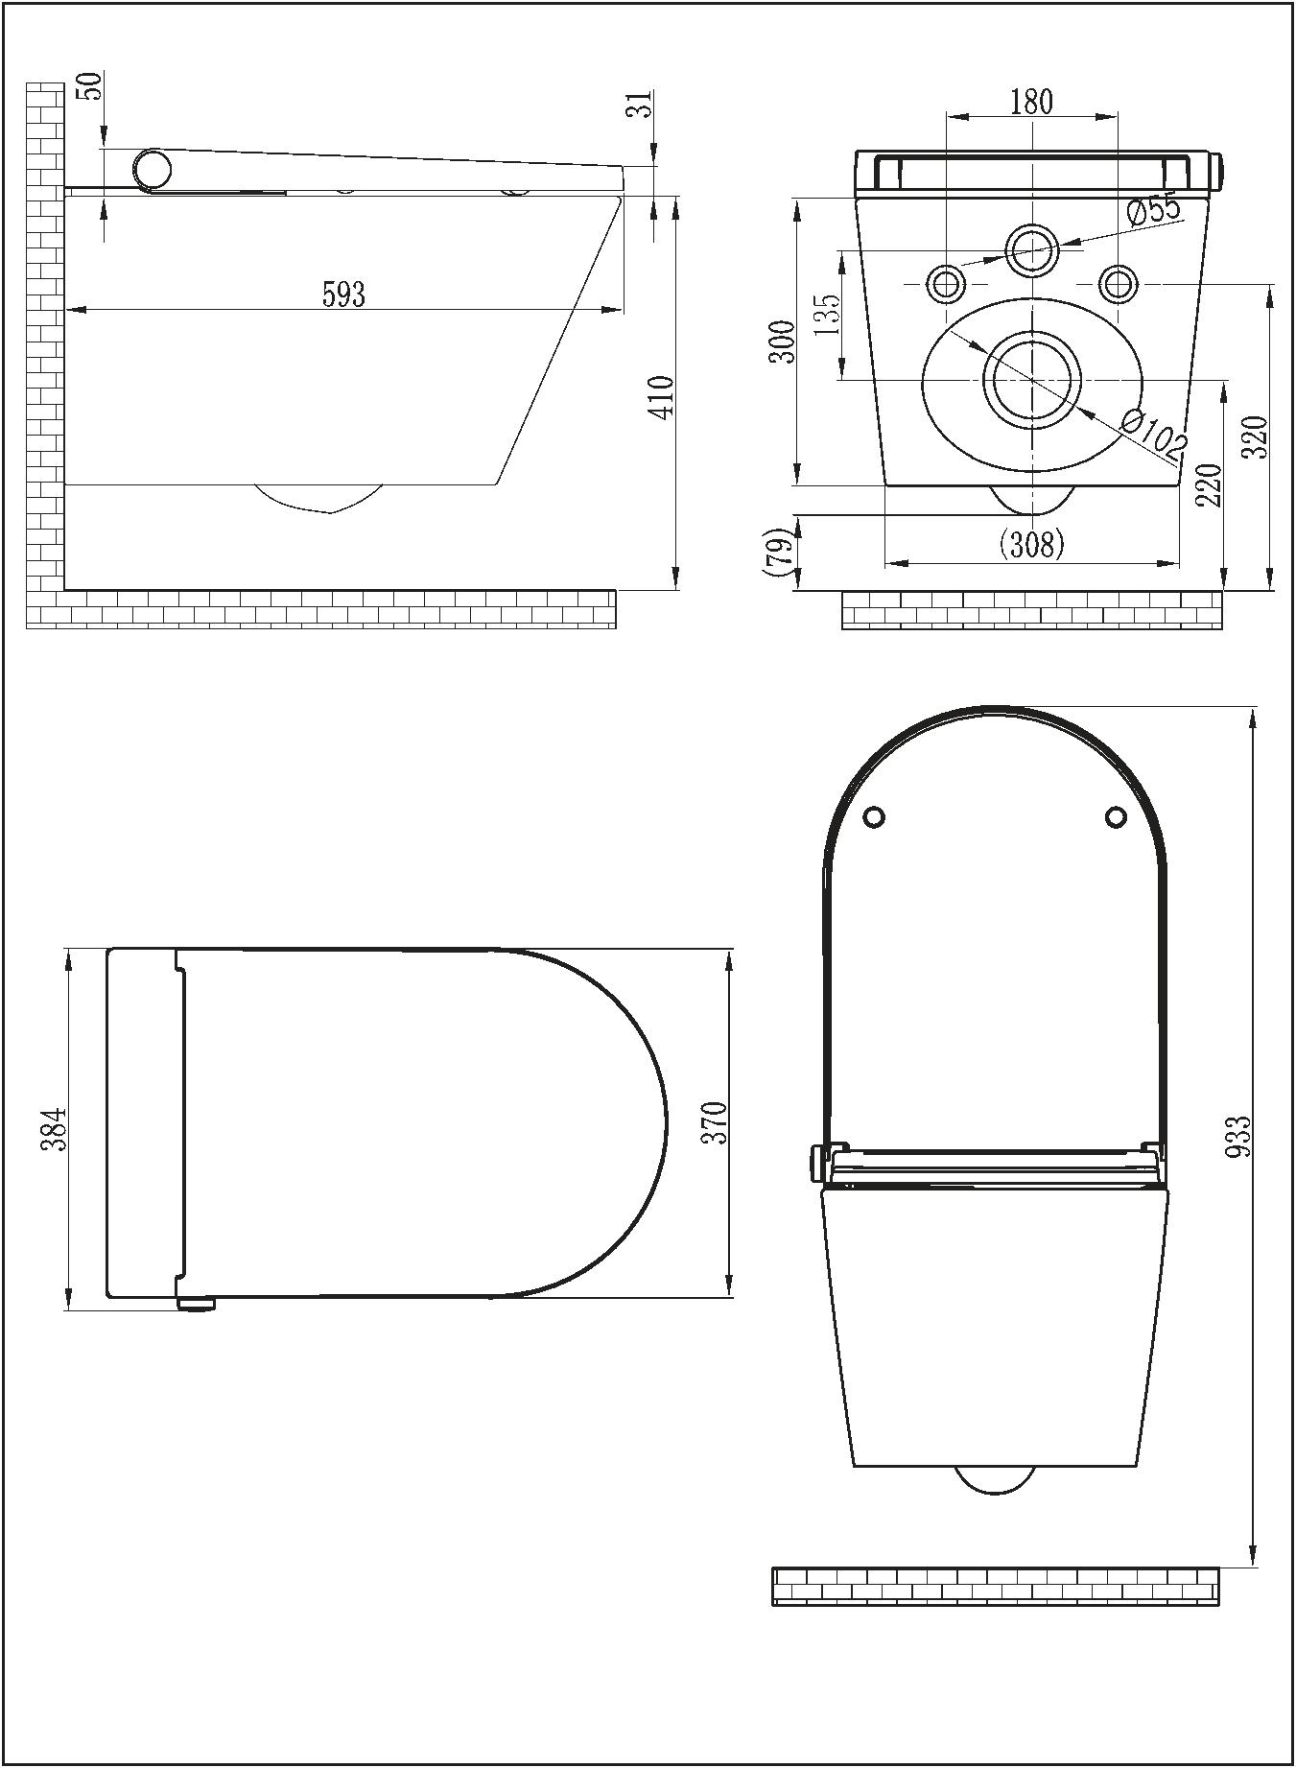

Technical Drawing
E400-F011
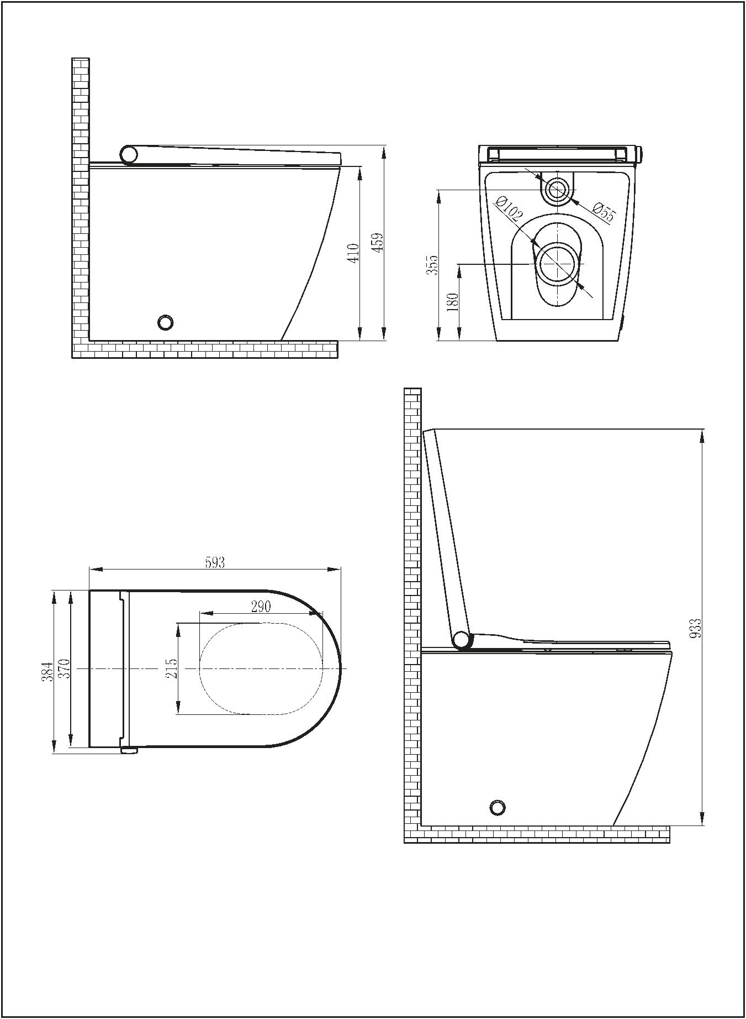

Technical Drawing
E401-W011
5
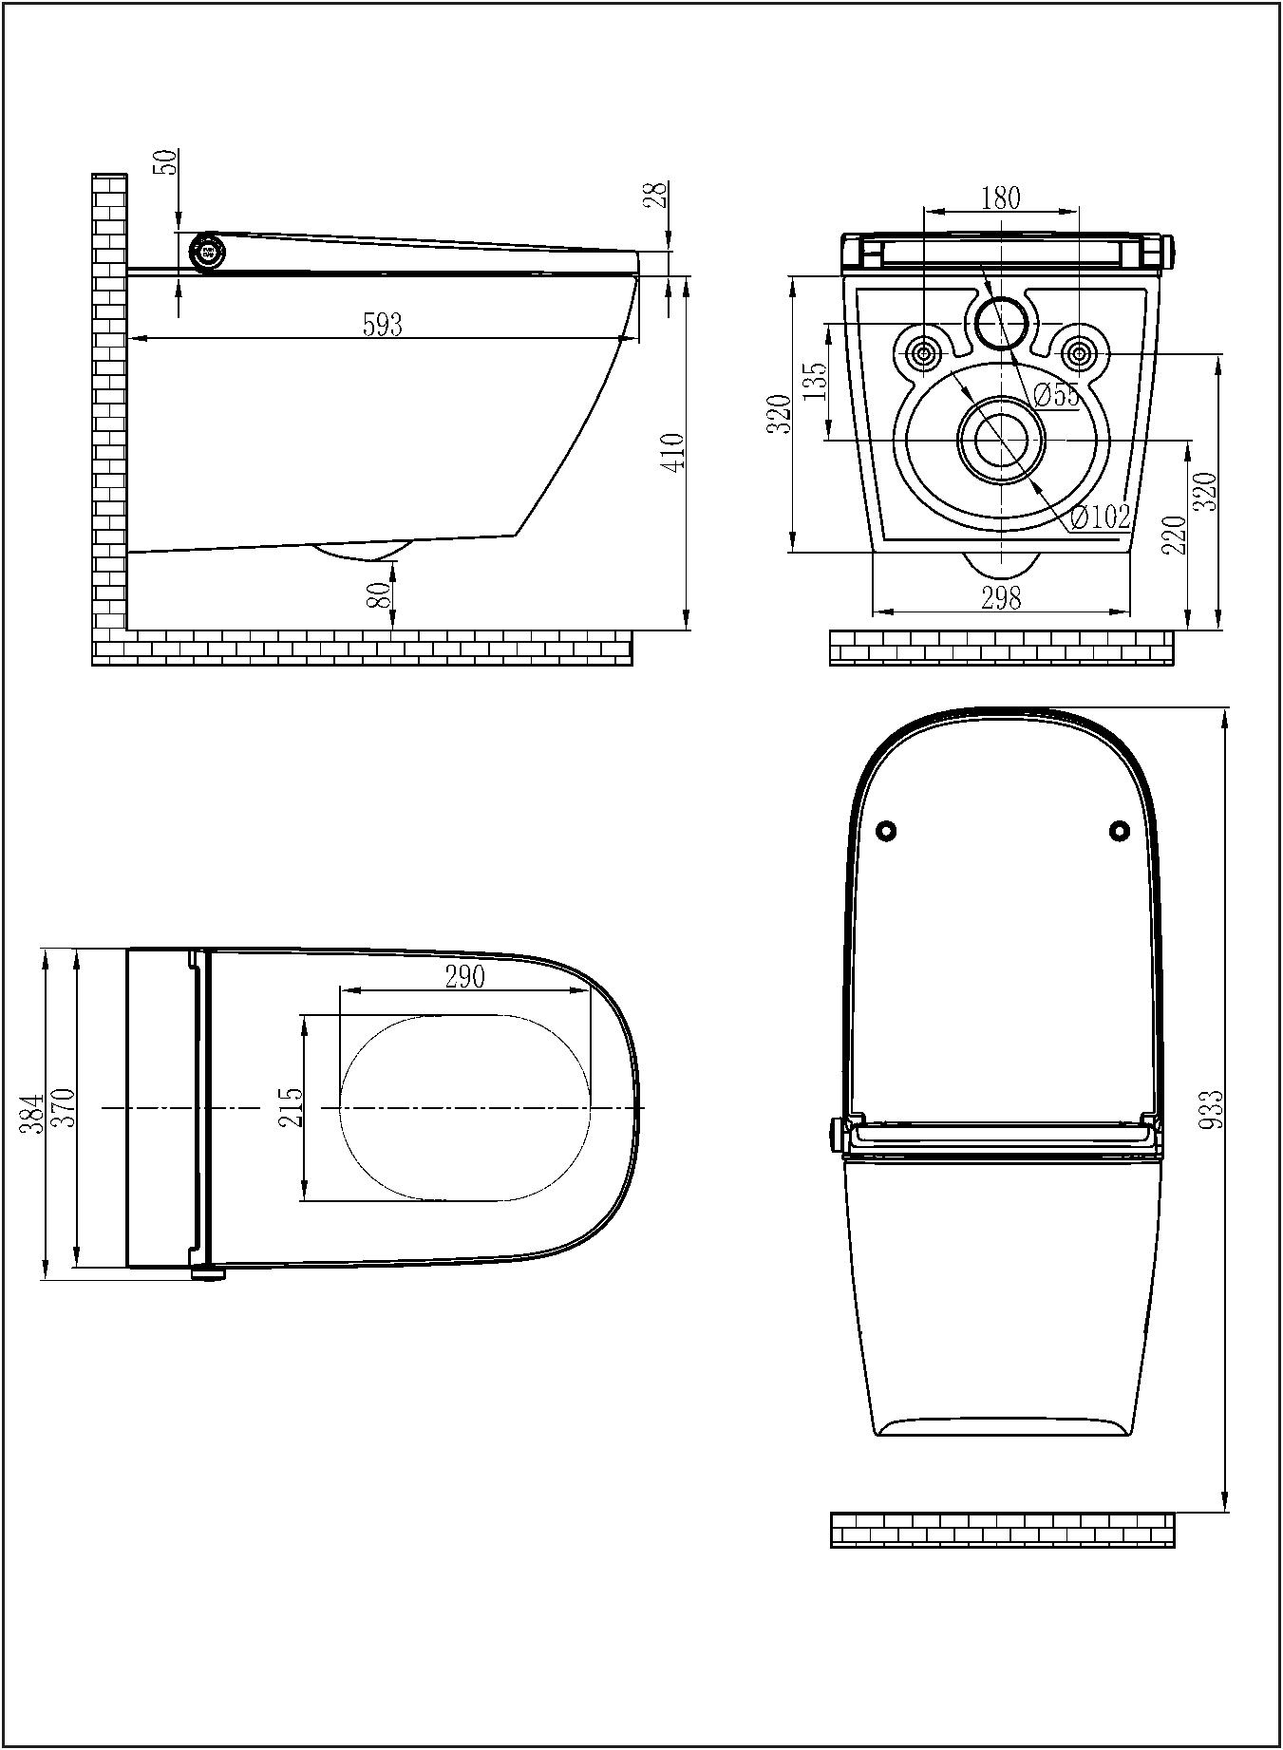

Overview
Cover
Seat detector
Dryer
Breathing lamp
Night light
Rear wash
Female wash
Knob
Deodoriser
Seat
Toilet
The pictures of this instruction is for reference only .
Please subject to the actual product .
NOTICE
6
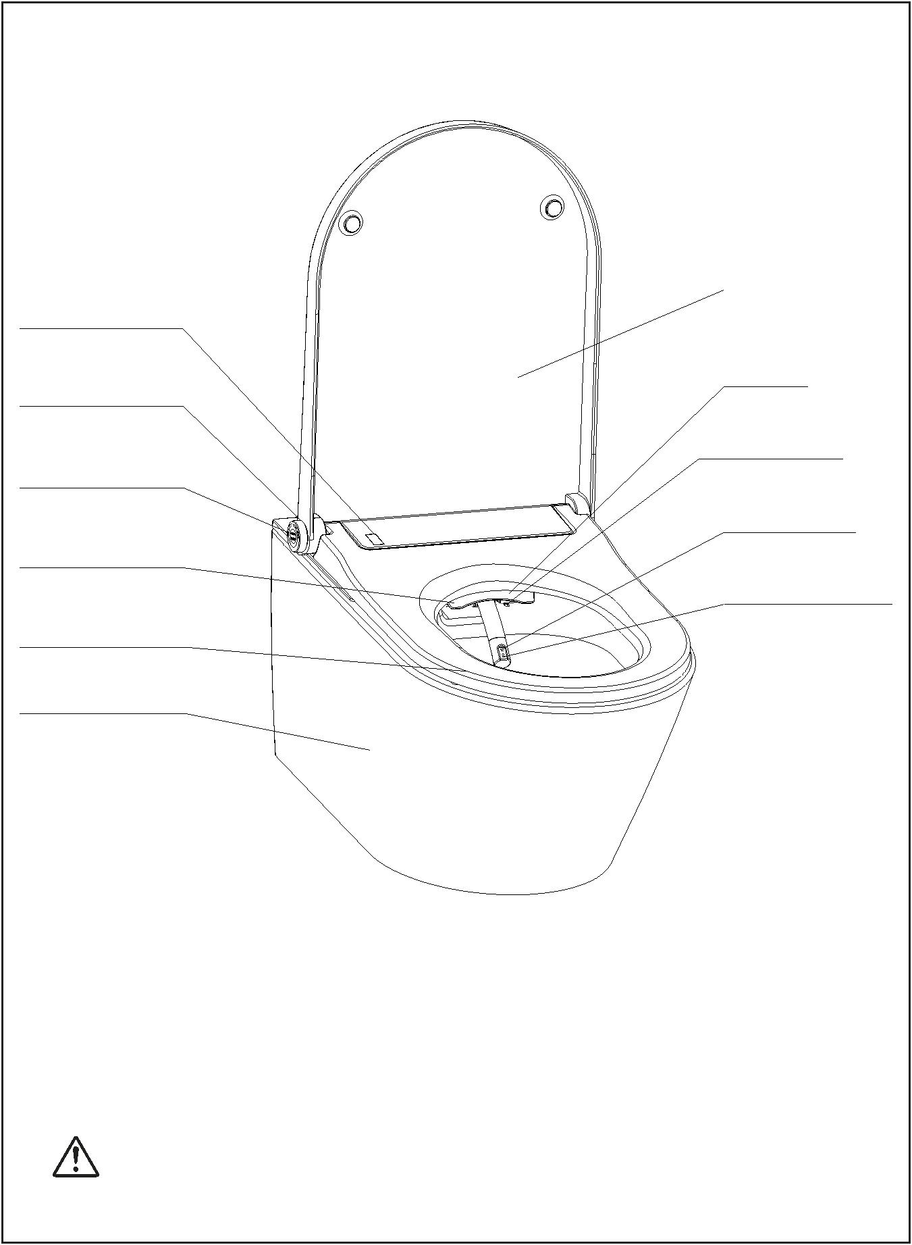

Remote Control
Female wash
Rear wash
Dry /
Stop
Steps
Increase flow /
Massage
Decrease flow
Increase
position /
Deodoriser
Decrease position /
Night light
Decrease
temperature /Shift
Increase
temperature /Shift
1.Before using,the remote control requires 2 batteries (type 3V CR2032)
2.Versions of Software : V1.0
NOTICE
(The software updates will not be notified. Please follow
the real remote control. )
7
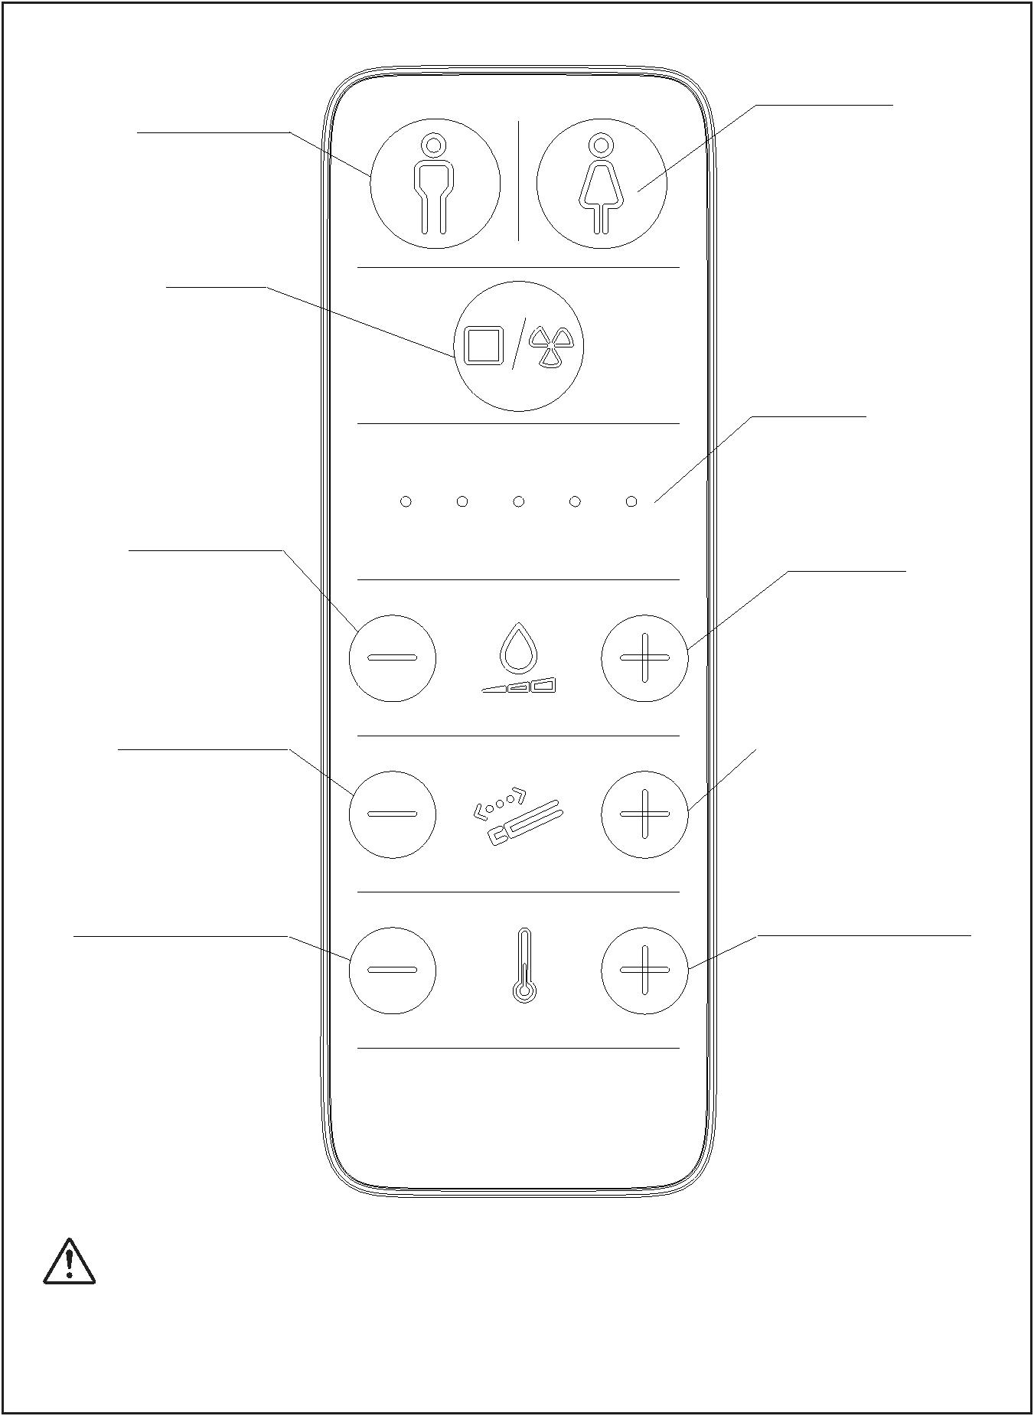

Rear wash /Female wash
● Be seated
Press the "Wash" button on the remote control then it start to wash.
It will stop after 3 minutes . You can stop washing before this by
pressing the "Stop" button.
Rear wash
Female wash
OR
You can operate by rotating the knob . Rotate the knob in
the clockwise direction to activate"Female wash" and the
anticlockwise direction for "Rear wash". It will stop after 3
minutes and start to dry . You can stop washing before this
Female wash
Rear wash
by pressing the "Stop" button.
Note: While Rear wash or Female wash , it will wash at the fixed position
for about 10 seconds , and movable wash for about 18 seconds , then
regain to the fixed position until to the end .
Dry Operation
Be seated
●
●
It is not in the process of Rear or Female washing
Press the "Dry" button on the remote control then it
start to dry. It will stop after 3 minutes
OR
Press the knob then it start to dry . It will stop drying after 3 minutes
All the operation is just for the model with all features . If the model what you
bought has no the feature , please ignore the corresponding operation .
NOTICE
8
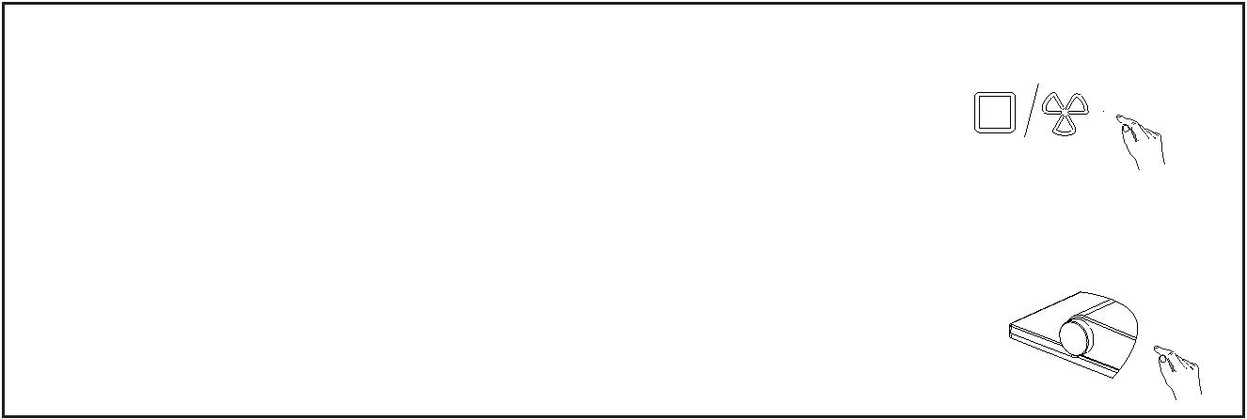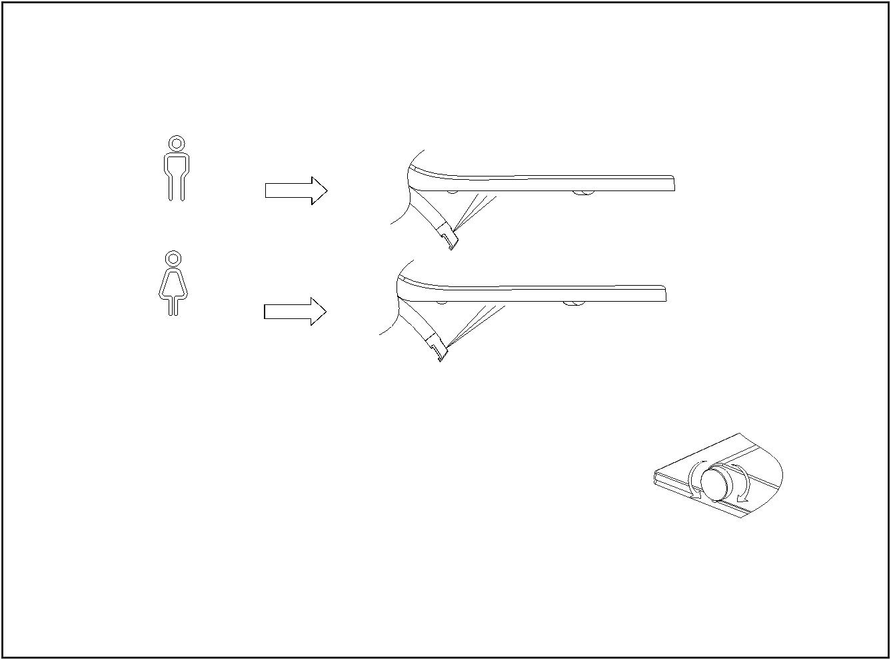

Massage Operation
In the process of Rear or Female washing
●
Keep pressing the "+ " or "-" button of temperature on the
remote control ,then press the "+" button of flow . Press it
again the wash will be on the diferent massage mode.
OR
Oscillating : when one indicator light is on
Pulsating : when two indicator lights are on
Oscillating + Pulsating : when three indicator lights are on
Stop Operation
●
In the process of Rear washing , Female washing or drying
Press the "Stop" button on the remote control it will stop washing or drying .
OR
Press the knob it will stop washing or drying
Adjusting water flow rate
● In the process of Rear or Female washing
Press the "+ " or "-" button of flow on the remote control to
adjust the flow rate . The indicator light of rate will be lighted up.
OR
You can operate by rotating the knob . The flow rate will
increase in the clockwise direction and decrease in the
anticlockwise direction .
Decrease
Increase
9
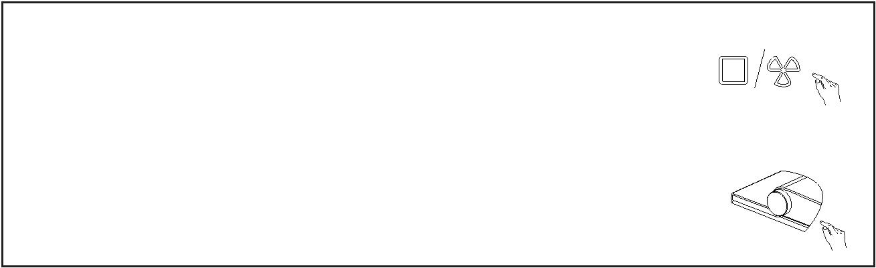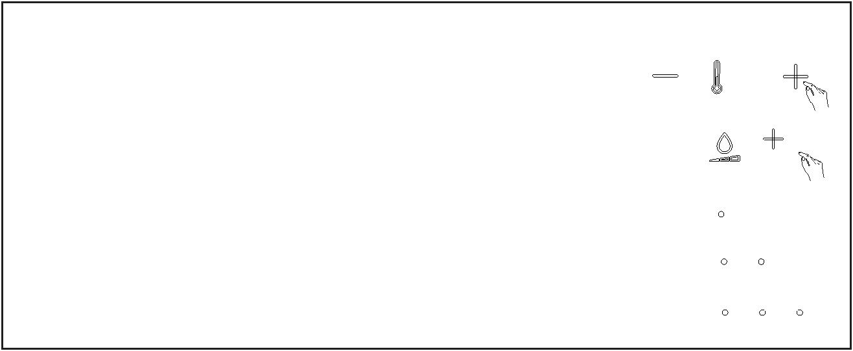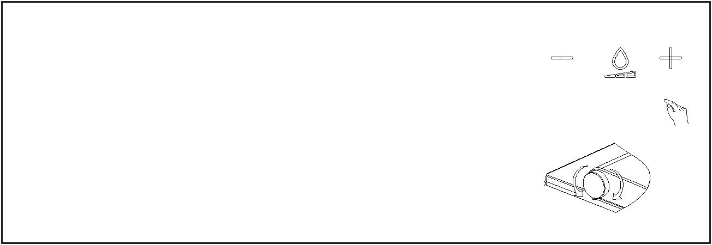

Adjusting the nozzle position
Default 5 th
●
In the process of Rear or Female washing
●
Press the"+ " or "-" button of flow position on the remote
control to adjust the nozzle position forward or backward.
Adjusting temperature
1.Adjusting water temperature
In the process of Rear or Female washing
●
Press "+ " or "-" button of temperature on the remote control
to adjust water temperature .
OR
Always press the knob and rotate it . The water
temperature will be increased in the clockwise direction
and be decreased in the anticlockwise direction .
Decrease
Increase
2. Adjusting air temperature
In the process of drying
●
Press the "+ " or "-" button of temperature on the
remote control to adjust air temperature .
OR
Always press the knob and rotate it .The air
temperature will be increased in the clockwise direction
and be decreased in the anticlockwise direction .
Decrease
Increase
10
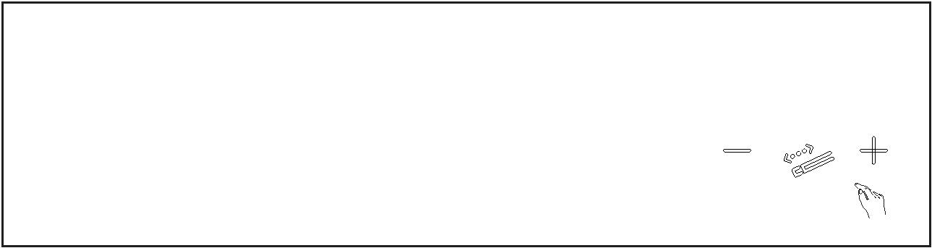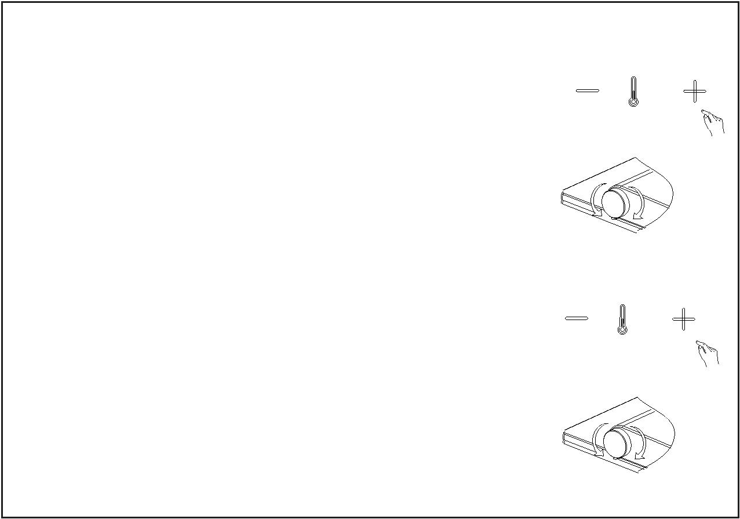

Night light Setting
● Always on mode for the night light by default
Keep pressing the "+ " or "-" button of temperature on the
remote control ,then press the "-" button of position . Press
it again the night light will be on the diferent mode just as
"close","always on","smart".
OR
Close mode : when one indicator light is on
Always on mode : when two indicator lights are on
Smart mode : when three indicator lights are on
OR
Open the cover and seat , not be seated , then rotate the knob
in the anticlockwise direction. The night light will be on the
diferent mode just as "close","always on","smart".
NOTE: The "smart" mode refers that the night light will light up in a
dark environment and light off in a bright environment.
DeodorizeSetting
Smart mode for the deodorization by default . It is on when the user sits
●
down and it will be off after one minute when the user leaves .
If there is no operation of washing or drying during being seated , it will
be off after 15 minutes.
Keep pressing the "+ " or "-" button of temperature on the
remote control ,then press the "+" button of position .
Press it again the deodorization will be on the diferent
mode just as "close" or "smart".
OR
Close mode : when one indicator light is on
Smart mode : when two indicator lights are on
OR
Open the cover and be seated , without washing and
drying , then keep pressing the knob and rotate it in the
clockwise or anticlockwise direction. The deodorization
will be on or off .
11
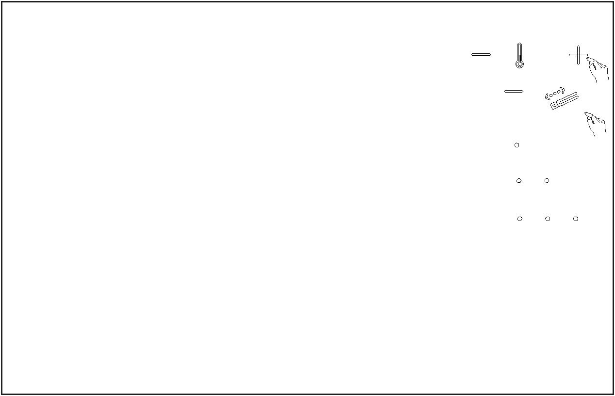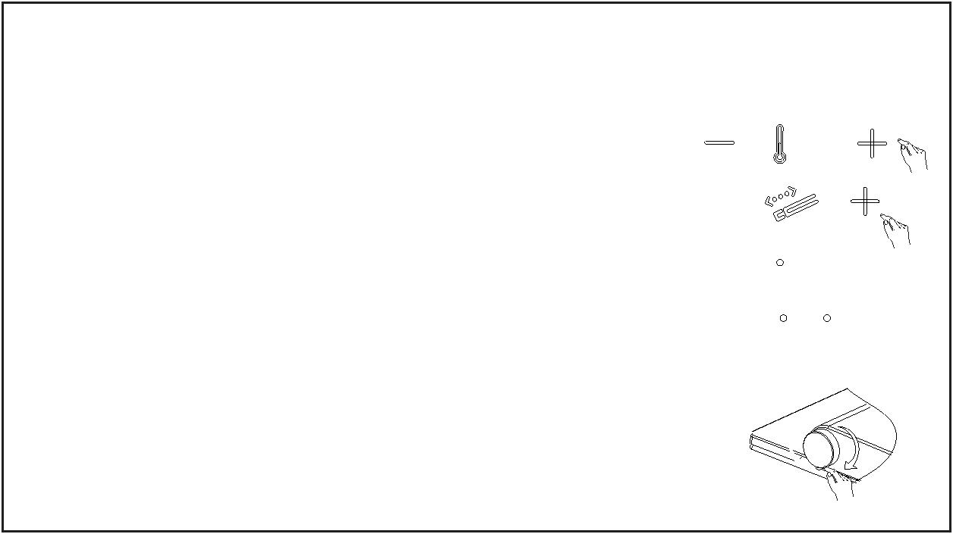

Breathing lamp setting
● Always on by default
Keep pressing the "+ " or "-" button of temperature on
OR
the remote control ,then press the "Rear wash" button .
The breathing lamp will be lighted off . It will be lighted up
when pressing the "Rear wash" again .
OR
● Be seated
Open the cover and be seated , without washing and
drying , then keep pressing the knob for 6S .The
breathing lamp will be lighted off . It will be lighted up
again when pressing the knob for 6S .
Power StandbySetting
● In the state without seating
Keep pressing the knob for more than 6seconds , it will go
into power standby mode .
＞6s
Press again the knob for more than 6 seconds to restart it .
Sound setting
● The sound is on by default. There is a BEEP when the
bidet has received commands or signals
Keep pressing the "+ " or "-" button of temperature on the
remote control ,then press the "Female wash" button .Press
it again the sound will be on or off.
OR
off mode : when one indicator light is on
on mode : when two indicator lights are on
OR
Open the cover and seat .
Keep pressing the knob then rotate it. The sound is
on in the clockwise direction and off in the
anticlockwise direction.
12
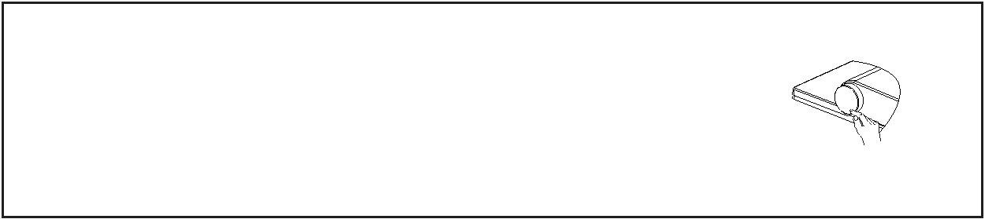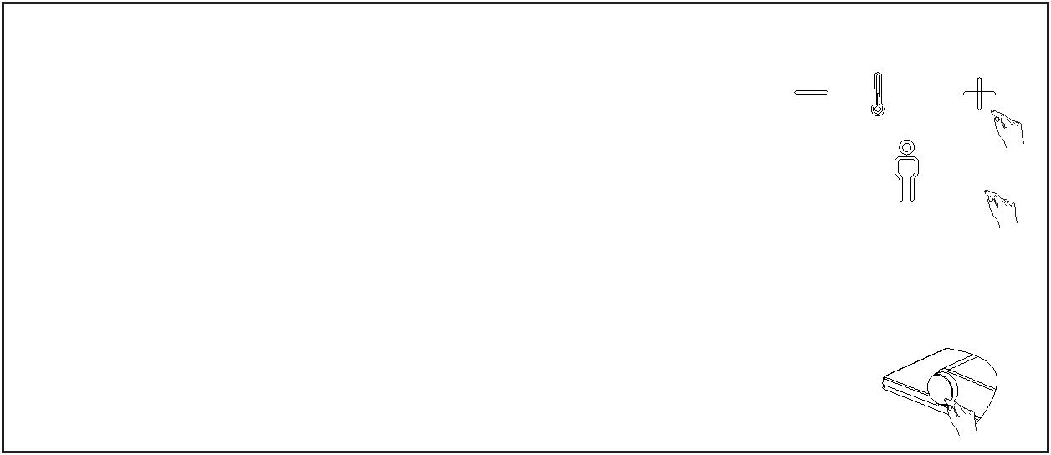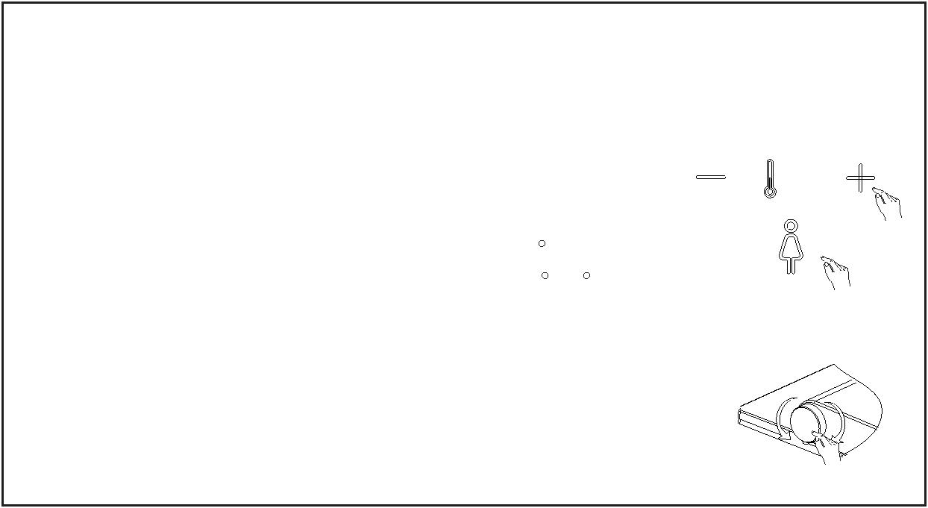

Care and cleaning
General care and cleaning recommendations
●
Maintaining interval
Maintaining activity
Remove water drops with a soft ,lint-free cloth to avoid
limescale stains
Daily
Clean all surfaces and corners .Clean the spray nozzle if
required.See "Nozzle cleaning "
Weekly
Clean the WC ceramic appliance with a low acidic cleaning agents
Monthly
Every half year
Replace the filter if required.
Cleaning agents and tools
●
For E-bidet
For WC ceramic appliance
soft cloths ,lint-free cloths
soft cloths ,lint-free cloths
low acidic cleaning
agents .e.g. heavily
diluted citric acid.
mild cleaning agents
that are kind to the skin.
toilet brush.
Do not use the cleaning agents of strong acid and alkali to clean the E-bidet ;
Do not use the hard brush .e.g. toilet brush nylon brush to clean the WC ceramic
appliance ;
FORBID
Do not use the metal brush.
Self-cleaning the tank
Not used for more than 72 hours, when the user operates the
washing ,it will open the self-cleaning for about 3 minutes. All the
buttons are invalid during the self-cleaning and it will return to normal
after the self-cleaning.
NOTICE
13
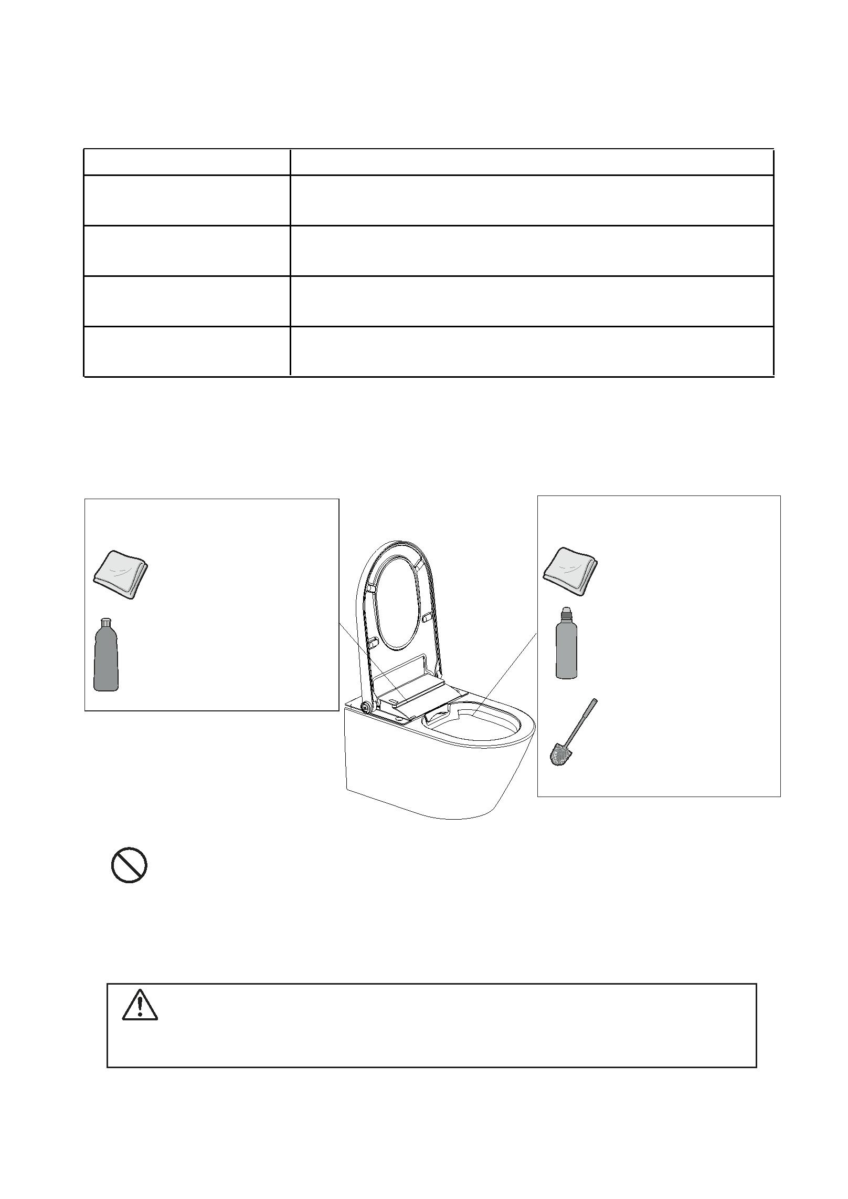

Nozzle cleaning
● The nozzle will be cleaned before washing and after washing .
The operation of manual cleaning is as follows
Open the cover and seat then rotate the knob in the clockwise
direction .Then the nozzle will extend with cleaning water. It will
return after 5 minutes or press the " stop " button .
A
B
C
D
E
Replacing the filter
● The filter has a service life of half a year . This is depended on the environment
of water. The filter should be replaced when the wash flow is too small .
A
B
C
D
a new one
14
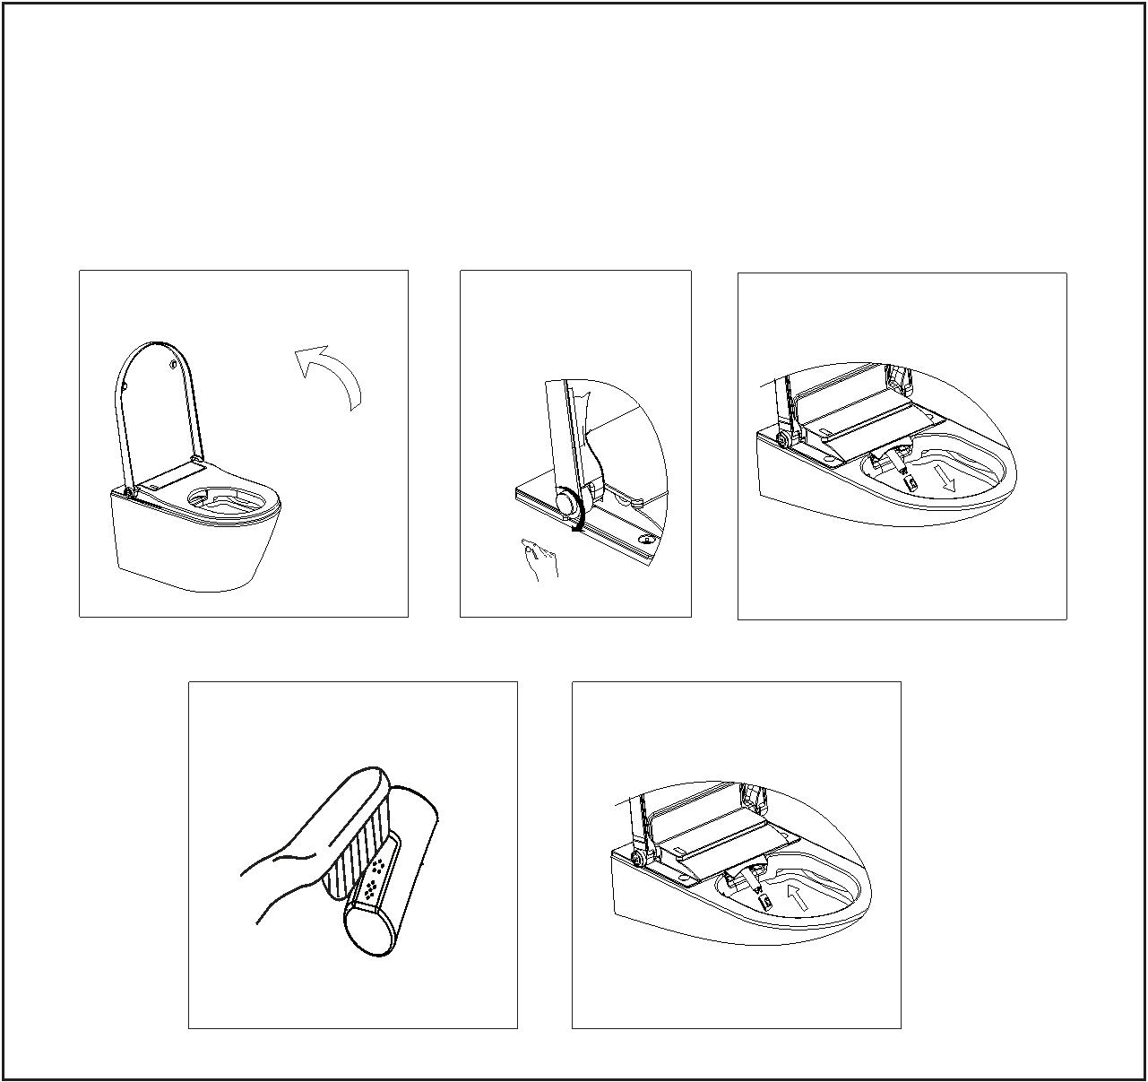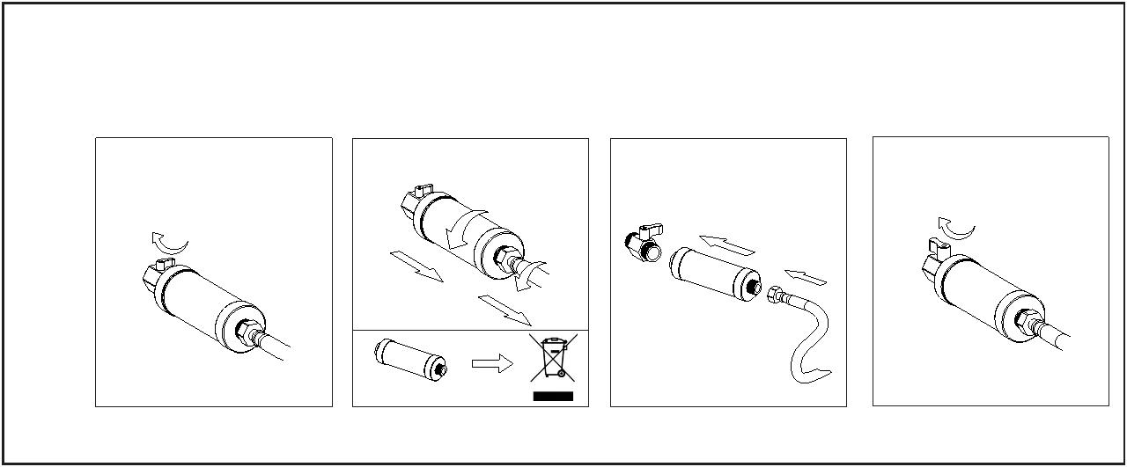

Drain the water tank
1.The water and power must be cut before you disassemble the E-Bidet
2.Do not invert or tilt it before you finish draining the water tank
'$1*(5
1.Hold the plug with the tipper , turn to
"open" , and pull out . It will start to drain .
2.After completing the drainage , insert
the plug and turn to "CLOSE" .
15
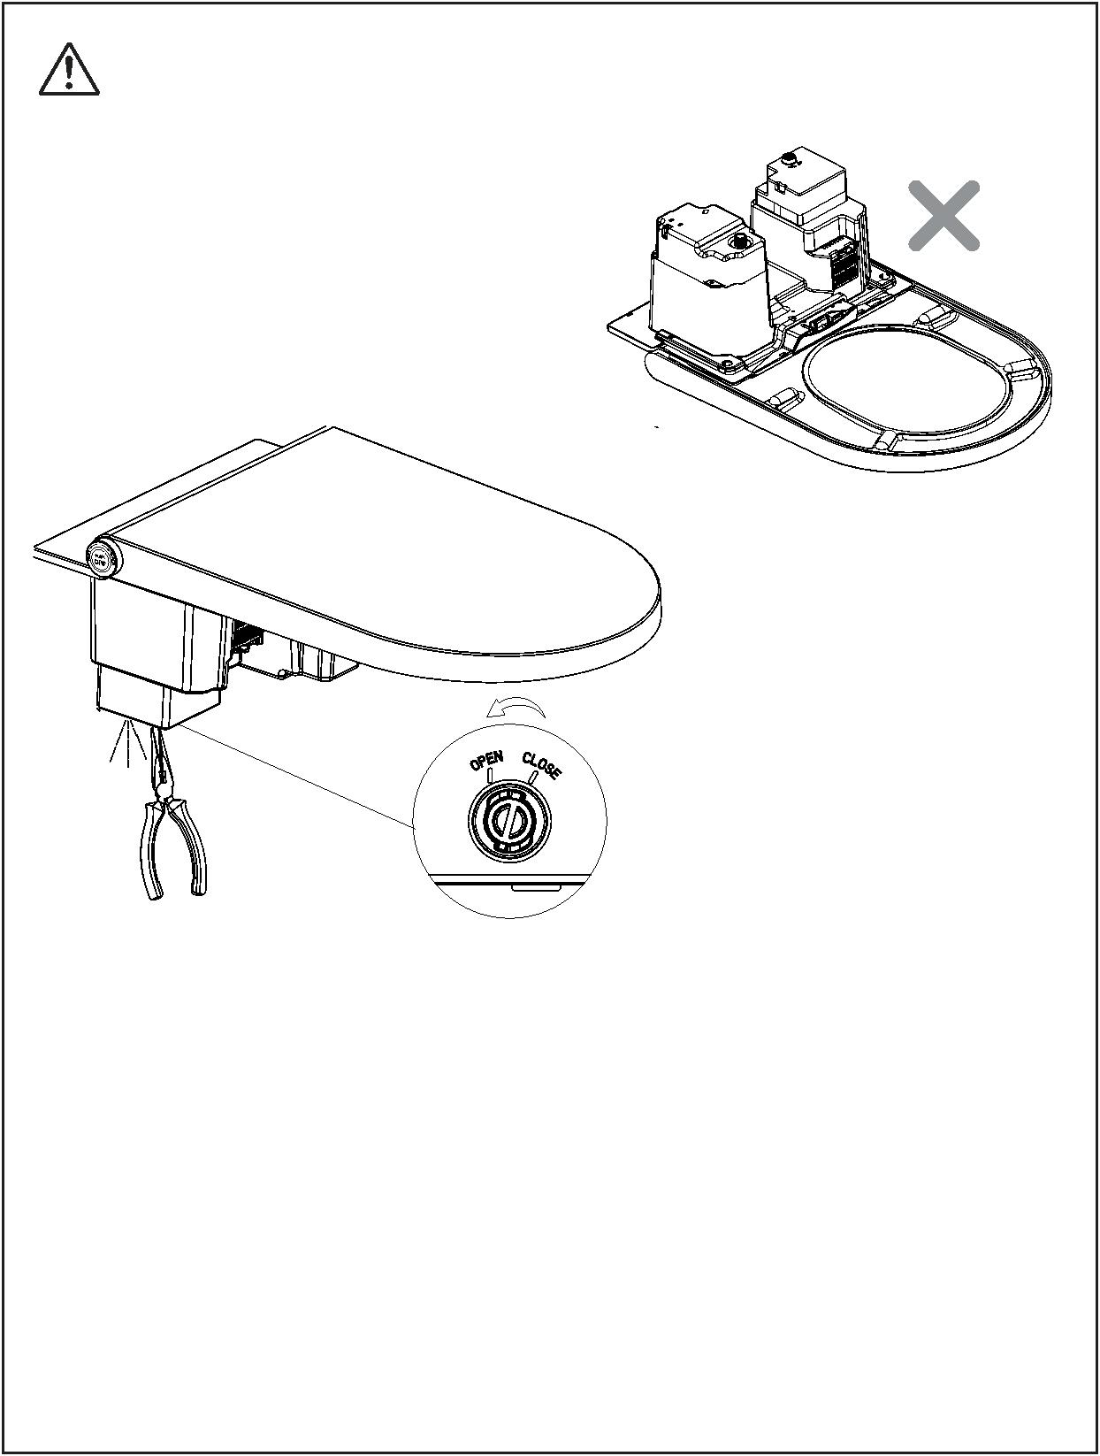

One-ON-One Setting
Install several electronic bidets in the same area, if you want each
●
remote control to control the specified electronic bidet, please complete
setting as per following steps.
1. Open both cover and seat and without seating. Set the night
light to the "close" model (just see the "Light setting ").
2. Keep pressing the "stop" button and "shift" button of adjust
temperature on the remote control at the same time for a few
seconds, then hear the "beep" from the product and meanwhile
the indicator light of first steps flicks.
3. Release the "stop" button, but keep pressing the "shift" button.
4.Press the "-" and "+" of the flow in order, and then release the
"shift"button. At this time, the lighted indicator is the current ID
code of product , and the 5th step light always flicks .
5.By pressing "-, +" buttons of the flow to change different
product ID code with corresponding indicator lights up. There
are 10 ID codes in total. It is on the first code by default and
the first step light lights up.
6.After selecting the product code ,press knob on the
bidet,then press the "stop" on the remote control.when
long "beep" sound heard,the setting is finished.
2
3
1
4
/
/
or
and
and
and
/
5
16
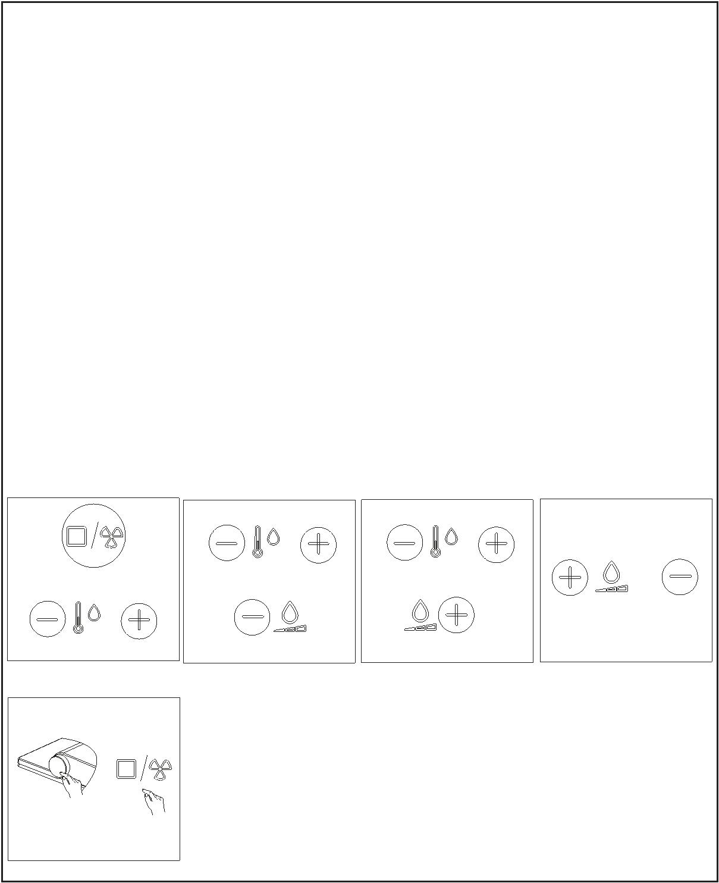

Replacing the batteries
The remotecontrolrequires 2 batteries (type3VCR2032).
●
●
When the level light flashes continuously , please replace the
batteries in time.
127,&(
1. Non-rechargeable batteries are not to be recharged
2. Rechargeable batteries are to be removed from the appliance before being charged
3.
Different types of batteries or new and used batteries are not to be mixed
4. Batteries are to be inserted with the correct polarity
5. The exhausted batteries are to be removed from the appliance and safely
disposed of
6. If the appliance is to be stored unused for a long period, the batteries
should be removed
7. The supply terminals are not to be short-circuited
B
Type: CR2032
A
C
17
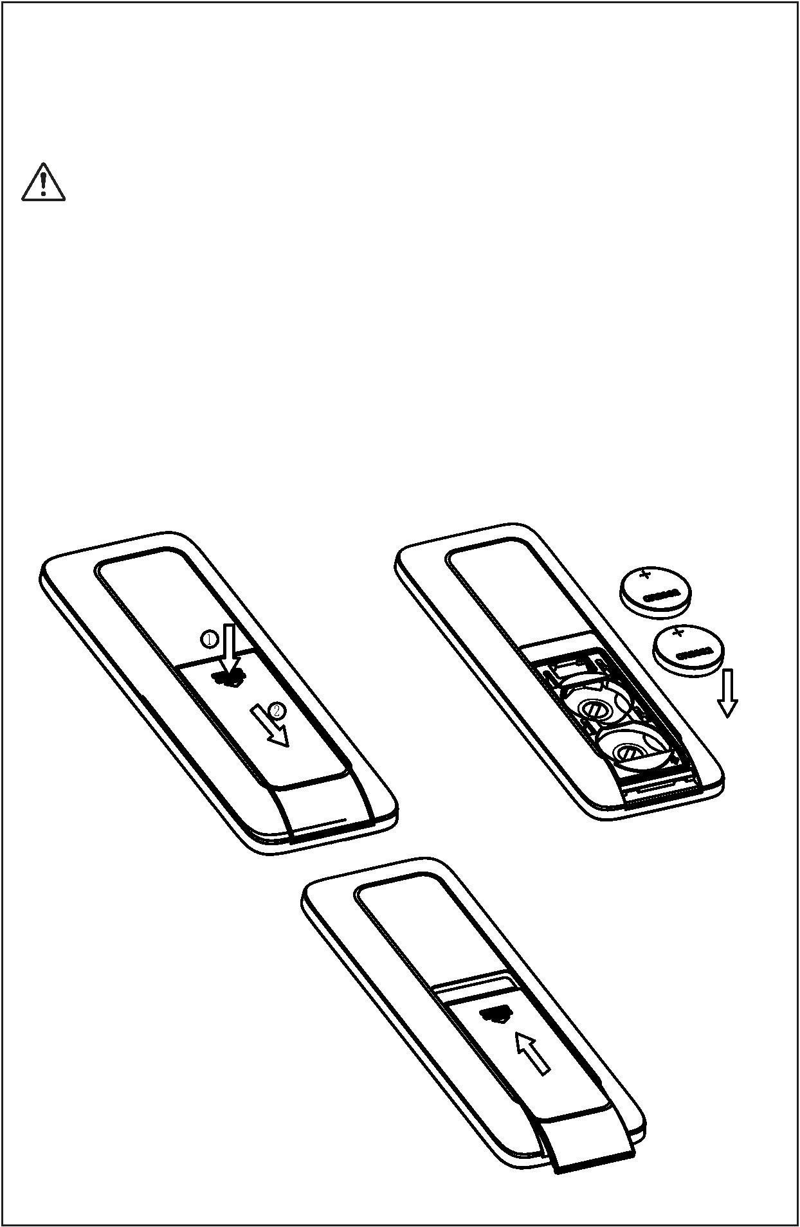

ꢀTroubleshooting
Problem
Potential cause
Suggested action
1. The power supply may not be opened
2. The water supply may not be opened
3. The filter may be blocked
Please turn on the power
Please open the inlet water valve,or check if there is a water outage
Please replace a new filter .It has a service life of approx. half a year
Please sit on the seat and adjust sitting position
The washing can not work
4.Maybe not in the seating state
5.Maybe the cover is closed
Please open the cover and sit on the seat
Not used for more than 72 hours ,when the user operates the washing ,it will open the
self-cleaning for about 3 minutes. All the buttons are invalid during the self-cleaning
and it will return to normal after the self-cleaning
6.Maybe it is not used for more than 72 hours
1.The washing cycle is 3mins. The nozzle will stop
spraying after 3mins ,and then go back.
This is normal and please re-press the "wash" button to start washing again
Please check if there is a water outage
2.There may be some problems of water supply
The nozzle goes back suddenly
3.Maybe the seated sensor detects the user left the seat Please adjust sitting position
4.Maybe the cover is closing
Do not put down the cover when it is washing
Please increase the flow rate as per "adjusting water flow rate" of operating
instructions
1.The water flow rate may be set at low grades
2.The water supply pressure may be too low
3.The filter may be blocked
Please check and ensure the water supply pressure is ̱0.07Mpa
Please replace a new filter .It has a service life of approx. half a year
Please replace a new nozzle
Low water flow rate
4.The nozzle may be blocked
Please set the water temperature at high grade as per "adjusting temperature"of
operating instructions
Please set the water temperature at high grade as per "adjusting temperature"of
operating instructions,or decrease the flow rate as per "adjusting water flow rate" of
1.The water temperature may be set at low grades
2.Maybe the temperature of water supply is too low
Low water temperature
When start washing function,the nozzle will be self-
cleaning before coming out,and this will take some
The nozzle comes out slowly
This is normal
1.When start washing function,the nozzle will be self-
cleaning before coming out .When the washing is over This is normal
,also have this feature
The water flows out but the nozzle
do not come out
This is normal. Not used for more than 72 hours ,when the user operates the washing
,it will open the self-cleaning for about 3 minutes
2.Maybe it is not used for more than 72 hours
1. The power supply may not be opened
2.Maybe not in the seating state
3.Maybe the cover is closed
Please turn on the power
Please sit on the seat and adjust sitting position
Please open the cover and sit on the seat
The dryer can not work
Not used for more than 72 hours ,when the user operates the washing ,it will open the
self-cleaning for about 3 minutes. All the buttons are invalid during the self-cleaning
and it will return to normal after the self-cleaning
4.Maybe it is not used for more than 72 hours
Please set the air temperature at high grade as per "adjusting temperature"of
operating instructions
1.The air temperature may be set at low grades
2.The air heater can not work normally
1.Maybe in the bright environment.
Low air temperature
Please contact local distributor
When the night light is set at smart mode,the night light will not work when in the bright
environment.
Night light is always off
Please open the night light function and adjust the night light mode as per "Light
Setting" of operating instructions
2.The night light function may be closed.
1.Maybe in the dark environment.
When the night light is set at smart mode,the night light will be always on when in the
dark environment
Night light is always on
2.Something may be covered around the knob.
3.The night light may be set at always on mode
1.The nozzle goes back after washing 5 minutes.
Recover the obstructions around the knob
Please adjust the night light mode as per "Light Setting" of operating instructions
This is normal
The nozzle goes back automaticlly
when manual cleaning
The manual cleaning will be stopped if press the knob or press the "stop" button on
the remote control.
2.Maybe press the "stop" button
3.Maybe the seated sensor detects that the seat is
closing
Please do not put down the seat during the manual cleaning
1.Maybe there are not batteries in the remote control
2.Maybe the battery power is too low
Please install the correct batteries in the remote control
The remote control is not
functioning
When the battery power is too low the LED of grade will flash.Please replace the
battery
3.Maybe the code of the bidet and remote control is not Please set the code of the remote control to the correct one .See "One-On-One
the same
Setting"
There is a short BEEP when you are sitting down , and a
long BEEP when you leave. Also there is a short BEEP This is normal. You can turn off the sound. See "Sound Setting"
when the bidet has received commands.
There are BEEP sounds when the
bidet is working
Please shut off the power and turn on after one minute. If the bidet still cannot
work,please contact local distributor
The bidet can not work normally Maybe there is something abnormal
The light around the knob flash
twice with constantly BEEP
Please shut off the power and water supply,stop using the product,and then contact
local distributor
The water supply temperature may be too high
There may be something wrong with the product
The light around the knob keep
flashing
Please check if the electric power and water supply are normal,cut off the power and
restart the product. If the bidet still cannot work,please contact local distributor
18
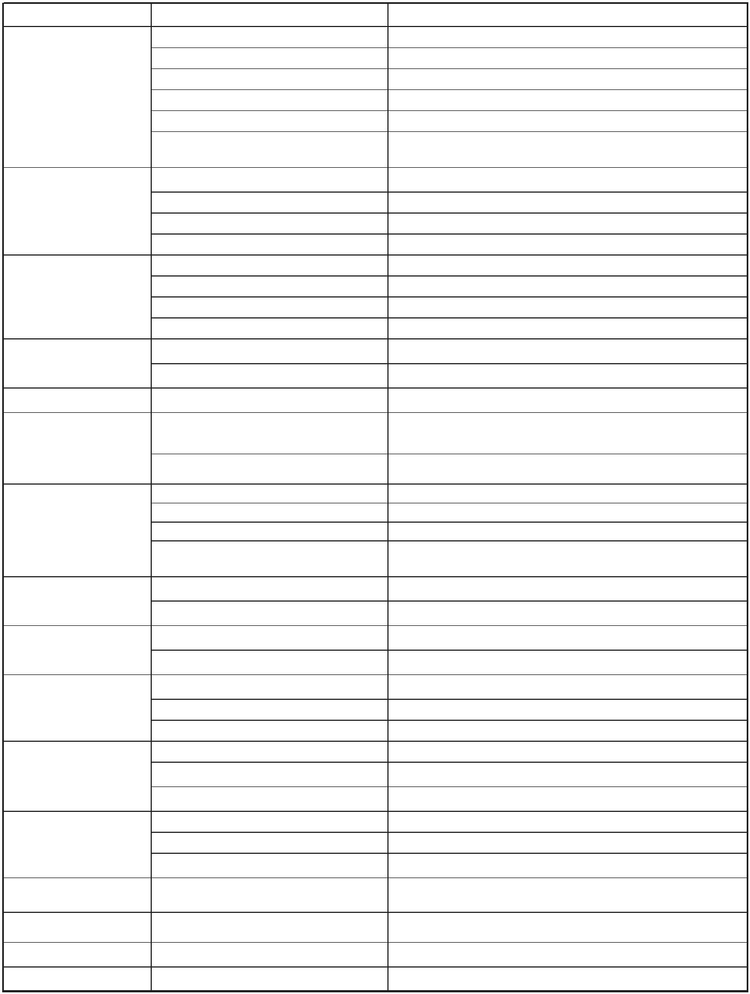

NOTICE
Do not dispose of electrical appliances as unsorted municipal waste, use
separate collection facilities.
Contact you local government for information regarding the collection systems
available. If electrical appliances are disposed of in landfills or dumps,
hazardous substances can leak into the groundwater and get into the food
chain, damaging your health and well-being. When replacing old appliances
with new ones, the retailer is legally obligated to take back your old appliance
for disposals at least free of charge.
236E400-OCW-02
Revision No. 1.1
Date of Revised: 2025/01/10
19
